SHELLX – STUDENT LINUX TOOLKIT
A Project Based Learning Report Submitted in partial fulfilment of the requirements
for the award of the degree
of
Bachelor of Technology
in The Department of Electronics and Communication Engineering
OPERATING SYSTEMS AND SYSTEMS PROGRAMMING (25CS2104E)
Submitted by
2510030379-POTNURU BHAVYA
2510030350-SEJAL HEDA
2510030325-BACHANGARI SIRI
2510030330-THOTA LAKSHMI HANSIKA
Under the guidance of
DR.PAVAN KUMAR PAGADALA


Department of Electronics and Communication Engineering
Koneru Lakshmaiah Education Foundation, Aziz Nagar
Aziz Nagar – 500075
OCT-2026

Abstract
ShellX – Student Linux Toolkit is a C-based terminal application developed to provide a simple, menu-driven interface for commonly used Linux activities. The project combines practical Linux and C programming tasks into one lightweight toolkit. The implemented modules include File Manager, Command Runner, Notes Manager, Calculator, System Information, Password Generator, and Interactive Command Mode.
The application uses standard C functions, file handling, command execution, string and numeric input, and reusable header/source files. The terminal interface is enhanced using ANSI escape sequences and Unicode box-drawing characters. A Makefile is used to automate compilation. The supplied project screenshots demonstrate the actual project directory structure, the main menu, password generation, and system-information functionality.
Keywords: C programming, Linux, terminal application, file management, command runner, notes manager, Makefile, TUI.

List of Figures
Figure 1. ShellX project directory structure
Figure 2. ShellX main menu
Figure 3. Password Generator output
Figure 4. System Information – Memory Information output

List of Tables
Table 1. ShellX functional modules
Table 2. Project directory and purpose
Table 3. Functional testing results
Table 4. Screenshot-based project evidence

Table of Contents
1. INTRODUCTION
2. METHODOLOGY
2.1 System Design and Module Selection
2.2 Software Architecture
2.3 User Interface Methodology
2.4 Build Methodology
3. EXPERIMENTS
3.1 Development Environment
3.2 Functional Modules
3.3 Project Directory Structure
3.4 Screenshot-Based Experiments
4. RESULTS
4.1 Functional Testing
4.2 Screenshot-Based Evidence
4.3 Methodology Evaluation
5. CONCLUSION AND FUTURE WORK
REFERENCES

1. INTRODUCTION
Linux provides a powerful command-line environment in which users can manage files, inspect system information, run commands, manipulate text, and automate routine tasks. For students learning Linux and C programming, however, working with many independent commands can make the learning process fragmented. ShellX was developed as a small integrated toolkit that brings several common activities together through a single terminal application.
The main objective of ShellX is to create a student-friendly Linux toolkit using fundamental C programming concepts. Instead of building a large graphical application, the project focuses on a terminal-based user interface. The main menu provides numbered options and each option transfers control to a separate functional module. This structure makes the application easier to understand, test, demonstrate, and extend.
The File Manager module demonstrates file creation, deletion, and directory listing. The Command Runner provides predefined Linux commands such as ls, pwd, whoami, and date. The Notes Manager demonstrates persistent text storage using file operations. The Calculator demonstrates arithmetic processing and division-by-zero validation. The System Information module retrieves useful information such as the current user, current directory, date and time, memory usage, and disk usage.
The Password Generator creates random alphanumeric passwords based on a requested length. An additional Interactive Command Mode makes the toolkit more flexible by allowing Linux shell commands to be entered directly. This provides a practical bridge between a menu-driven toolkit and normal Linux command-line usage.
The project follows a modular source-code organization. Header files contain declarations and shared definitions, while C source files contain implementations. Utility code for the terminal interface is kept separately from the feature modules. The supplied project directory screenshot shows separate locations for headers, source modules, utilities, data, documentation, build files, configuration, tests, and the executable.
ShellX also demonstrates how build automation can support a C project. A Makefile is used to automate compilation and reduce the need to repeatedly type a complete gcc command. The compiled application is stored in the bin directory, while documentation and persistent data are kept separately. This organization improves maintainability and makes the project easier to explain during academic evaluation.
The project is therefore not only a collection of Linux commands. It integrates Linux operations, C programming, file handling, terminal interface design, modular source organization, validation, and build automation into one student-oriented application. The supplied runtime screenshots provide evidence that the application can display its main menu, generate a password, and retrieve system memory information.

2. METHODOLOGY

2.1 System Design and Module Selection
The methodology began by identifying Linux activities that are useful for students and can be implemented using basic C programming. These activities were grouped into independent modules so that each feature could be developed and tested separately. The main program acts as the controller and displays the menu, accepts the user's selection, and calls the corresponding module.

2.2 Software Architecture
ShellX is organized into an include directory for header files, a src directory for implementation files, a data directory for persistent text data, a bin directory for the compiled executable, and a docs directory for project documentation. The source tree also separates feature modules under src/modules from reusable utilities under src/utils.
The separation between header and source files improves maintainability. Header files provide function declarations that can be shared by multiple source files, while corresponding C files contain implementations. The project tree supplied by the team demonstrates this modular organization through files such as calculator.h, command_runner.h, file_manager.h, interactive_shell.h, notes_manager.h, password_generator.h, system_info.h, shellx.h and ui.h.

2.3 User Interface Methodology
The user interface is a terminal-based interface rather than a graphical interface. Standard C output functions are used to display menus and messages. ANSI escape sequences provide terminal colors and formatting, while Unicode box-drawing characters provide visual borders. The main-menu screenshot demonstrates the resulting structured presentation.

2.4 Build Methodology
Compilation is automated using a Makefile. The build process compiles the main program, feature modules, and utility modules and links them into the ShellX executable. The project directory screenshot shows the Makefile and the generated ShellX executable under the bin directory.

3. EXPERIMENTS

3.1 Development Environment
The project was developed as a Linux terminal application using the C programming language and gcc. The application was tested in a Linux/WSL-style environment using standard C libraries and Linux command-line utilities available in the execution environment.

3.2 Functional Modules
Module | Main Function | Concept Demonstrated
File Manager | Create/delete files and list files | File I/O and Linux commands
Command Runner | Run predefined Linux commands | system() and command execution
Notes Manager | Add and view persistent notes | fopen(), fgets(), fprintf()
Calculator | Perform arithmetic operations | Input handling and validation
System Information | Display user, directory, date, memory and disk data | Linux utilities
Password Generator | Generate alphanumeric passwords | rand(), srand(), time()
Interactive Command Mode | Execute user-entered Linux commands | Shell command execution

Table 1. ShellX functional modules.

3.3 Project Directory Structure
The following table summarizes the major project items visible in the supplied terminal tree.
Project Item | Purpose / Contents
Makefile | Build automation
README.md | Project documentation
bin/ | Compiled ShellX executable
build/ | Build-related directory
config/ | Configuration directory
data/ | favorites.txt, history.txt and notes.txt
docs/ | architecture.md, commands.md and user_guide.md
include/ | Header files for project modules and UI
src/main.c | Main program/controller
src/modules/ | Calculator, command runner, file manager, interactive shell, notes, password generator and system information implementations
src/utils/ | Logger, UI and validator utilities
tests/ | Testing directory

Table 2. Project directory and purpose.

3.4 Screenshot-Based Experiments
The following experiments use screenshots taken directly from the developed ShellX application. The screenshots are included as evidence of the project structure and runtime behavior.
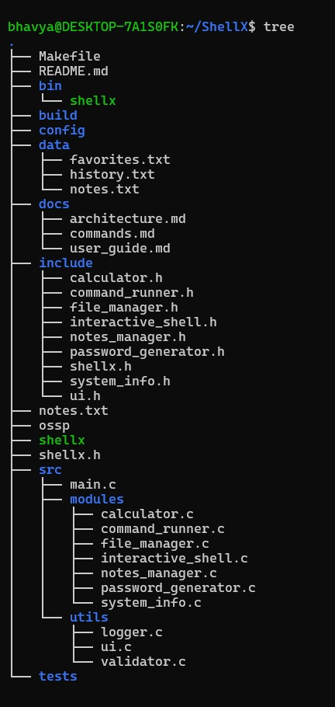
Figure 1. ShellX project directory structure.
The project tree demonstrates the modular organization of the application. Separate folders are visible for source files, feature modules, utility files, header files, documentation, data, build output, configuration and tests.
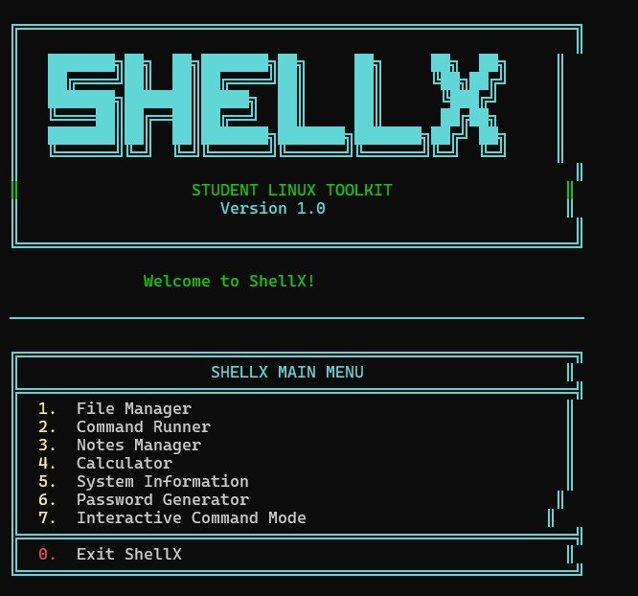
Figure 2. ShellX main menu.
The main menu provides the central entry point to the toolkit. It displays seven functional options and an Exit option. The formatted terminal interface includes the ShellX title, version information, welcome message and structured menu borders.
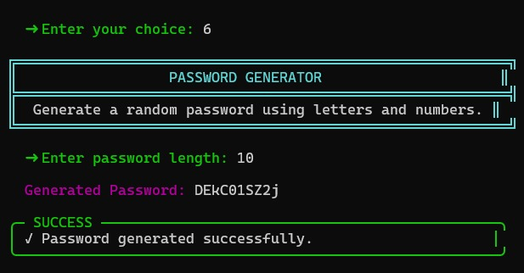
Figure 3. Password Generator output.
Option 6 opens the Password Generator. In the supplied experiment, the requested password length is 10. The application generates an alphanumeric password and reports that the password was generated successfully.
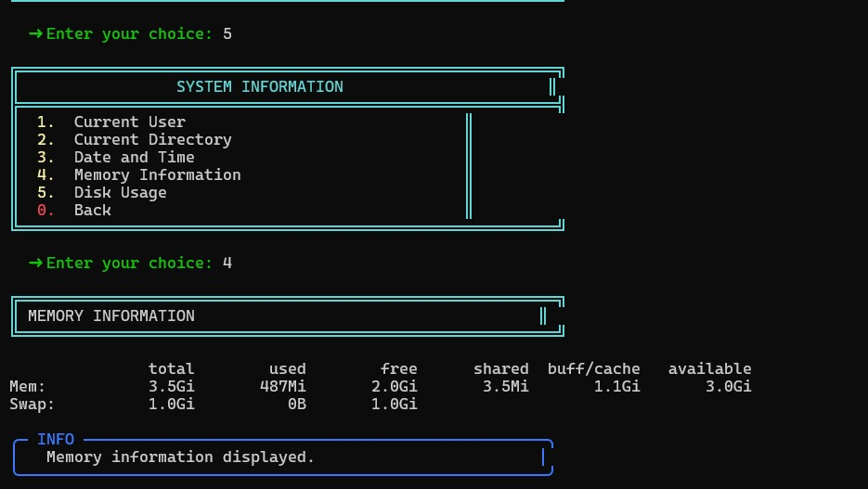
Figure 4. System Information – Memory Information output.
Option 5 opens the System Information module. The supplied experiment selects Memory Information and displays total, used, free, shared, buffer/cache and available memory values, followed by an information message.

4. RESULTS
The implemented ShellX modules were functionally tested through the terminal menu. The application provides a single entry point for the selected Linux utilities and returns to the main menu after module execution. The supplied screenshots demonstrate the project directory structure and visible runtime results for the main menu, password generation and system-information functionality.
Test | Expected Behavior | Observed Result
Launch ShellX | Main menu is displayed | Main menu displayed
Project directory | Project modules are organized | Directory tree displayed with modular folders and files
Password generation | Requested positive length generates a password | Length 10 accepted and generated password displayed
System information | Selected system information is shown | Memory information displayed
File creation | Requested file is created | File Manager supports file creation
File deletion | Requested file is removed | File Manager supports file deletion
List files | Current directory files are shown | Directory listing supported
Predefined command | Selected command executes | Command output supported
Add/view note | Note can be stored and read | Persistent note storage supported
Calculator | Arithmetic result is displayed | Arithmetic operations supported
Division by zero | Validation error is shown | Validation supported
Interactive command mode | User command executes | Interactive command execution supported

Table 3. Functional testing results.

4.1 Screenshot-Based Evidence
Figure | Feature | Evidence
Figure 1 | Project structure | Modular source, header, utility, data, docs, build and executable organization
Figure 2 | Main menu | Seven functional modules are available through the terminal interface
Figure 3 | Password Generator | Length input is accepted and a generated password is displayed
Figure 4 | System Information | Memory information is retrieved and displayed

Table 4. Screenshot-based project evidence.

4.2 Methodology Evaluation
The methodology is effective for a student project because each feature is isolated into a module with a clear purpose. The terminal interface keeps the implementation lightweight while structured formatting improves readability. The Makefile simplifies repeated builds, and the separation of source, headers, utilities, data and documentation improves maintainability.

4.3 Novelty of the Developed Methodology

The project combines several beginner-to-intermediate Linux operations into a single student-oriented toolkit rather than presenting them as unrelated command-line exercises. Interactive Command Mode additionally allows the same application to demonstrate both predefined utilities and general Linux shell operations.
5. CONCLUSION AND FUTURE WORK
ShellX – Student Linux Toolkit successfully integrates common Linux utilities and basic programming exercises into one menu-driven C application. The project demonstrates file handling, command execution, string processing, arithmetic operations, random password generation, modular source organization, terminal UI formatting, and build automation.
The actual project screenshots provide direct evidence of the implemented structure and runtime behavior. The project tree demonstrates modular organization, the main menu demonstrates the central user interface, the Password Generator demonstrates input and output handling, and the System Information module demonstrates retrieval and presentation of operating-system information.
Future work can include an ncurses-based interface with arrow-key navigation, richer file-management operations, safer command validation, improved password-generation randomness, searchable and editable notes, command history inside ShellX, configuration files, and more detailed system monitoring. These extensions can be added incrementally because the current modular methodology separates features and utilities.

REFERENCES
[1] GNU Project, GNU C Library documentation and C standard library reference.
[2] Linux manual pages (man pages) for ls, pwd, whoami, date, free, df, rm, mv, mkdir, touch, and related shell utilities.
[3] GCC documentation, GNU Compiler Collection documentation.
[4] GNU Make documentation, GNU Make manual.
[5] ShellX – Student Linux Toolkit project source code and documentation.

